**CSI 1**

***Question 1.***The second-generation computers used which technology to replace vacuum tubes?

A. Microprocessor

B. Transistor  
C. Integrated Circuit  
D. Magnetic Memory

**Answer: B**

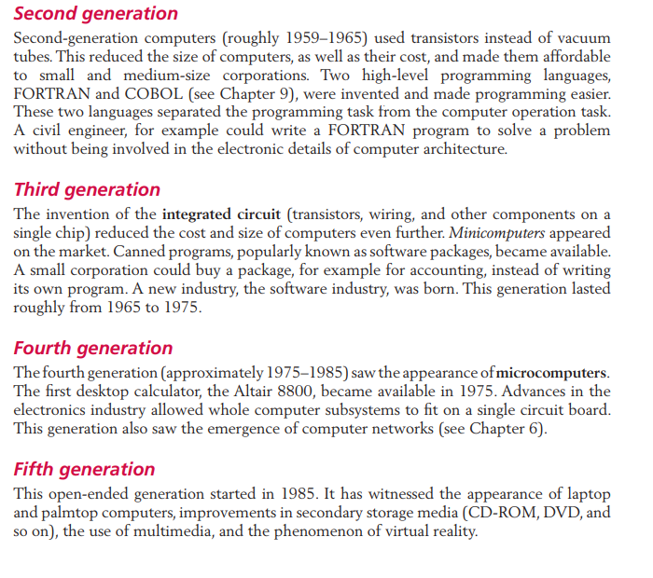

According to the book: page 11

Second-generation computers (1959–1965) used transistors to replace vacuum tubes, reducing size and increasing efficiency.

The other answers are incorrect because:

**A. Microprocessor**: Appeared in the fourth generation.

**C. Integrated Circuit**: Used in the third generation.

**D. Magnetic Memory**: Used for data storage, not as a replacement for vacuum tubes.

**CSI 2**

***Question 2.***How can we quickly convert a number from the binary system to the hexadecimal system?

A. Group every 3 bits from right to left

B. Divide the binary number by 16 and take the remainder

C. Group every 4 bits from right to left

D. Convert to the decimal system first, then to the hexadecimal system

**Answer:** **C**

Explain:

**Pages 29 – 30**

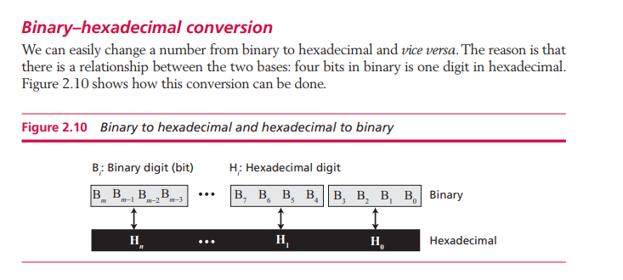

According to the book:

We can easily convert a number from the binary system to the hexadecimal system and vice versa. The reason is that there is a relationship between the two numeral systems: four bits in binary correspond to one digit in hexadecimal.

The other answers are incorrect because:

**A.** Grouping 3 bits is the method for converting to the octal system.

**B.** This is a method for converting between the decimal and hexadecimal systems, not binary.

**D.** This method may be correct but is not the fastest approach.

**CSI 03**

***Question 3****.*In storing floating-point numbers, how does the IEEE standard represent them?

A. Using sign-and-magnitude form with 8 bits for exponent and 23 bits for mantissa.

B. Using normalized binary form with 1 sign bit, 8-bit exponent, and 23-bit mantissa.

C. Using unnormalized binary with 1 sign bit and 31 bits for mantissa.

D. Using decimal form with 10 bits for exponent and 22 bits for mantissa.

**Correct Answer: B**

**Explanation:** The IEEE 754 standard for storing floating-point numbers uses a normalized binary form, represented with 1 sign bit, 8 bits for the exponent (in excess-127 representation), and 23 bits for the mantissa (fractional part). This is detailed in Chapter 3: Data Storage, under "Floating-point representation" and "IEEE standards," pages 52-58. Quote from page 56:

"The IEEE standards use a normalized binary number with one bit for the sign, eight bits for the exponent (in excess representation), and 23 bits for the mantissa."

Option A is incorrect because IEEE does not use sign-and-magnitude but a normalized form.

Option C is incorrect because IEEE requires normalization, not unnormalized representation.

Option D is incorrect because IEEE uses binary, not decimal, and the bit allocation (10 for exponent, 22 for mantissa) does not match the 32-bit standard.

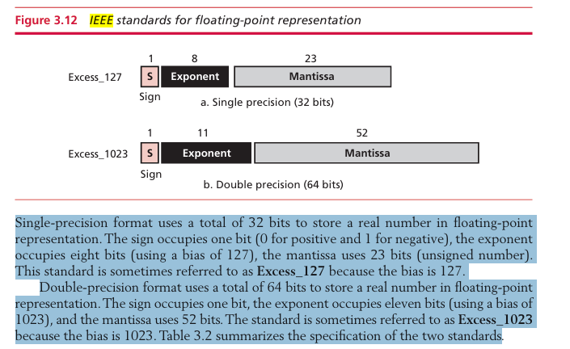

**CSI 04**

***Question 4.***In the network layer, what is the primary function of the IP protocol?

A. Ensuring data arrives at the destination in original order.

B. Providing routing and forwarding of packets across networks.

C. Dividing packets into smaller segments for transmission.  
  
D. Checking for errors in data within network packets.

**Correct Answer: B**

**Explanation with Evidence:** The primary function of the IP (Internet Protocol) in the network layer is to provide routing and forwarding of packets from the source to the destination across multiple networks, without guaranteeing order, error checking, or segmentation as its main task. This is detailed in **Chapter 6: Computer Networks and Internet**, under the section "Network Layer," pages 159-166. The most direct evidence comes from **page 160**:

"The main responsibility of the network layer is to provide routing and forwarding of packets from the source to the destination across multiple networks."

**A is incorrect** because IP does not guarantee ordered delivery; TCP handles that.

**C is incorrect** because segmentation is done by the transport layer, not IP.

**D is incorrect** because IP only checks its header, not the data; error checking is handled by other layers.

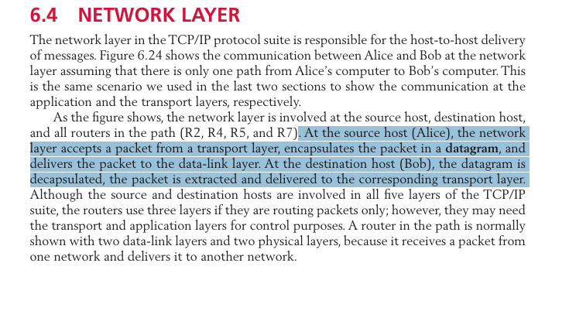

**CSI 05**

***Question 5.***What are the characteristics of the UNIX operating system?

A. Supports only a single user, meaning only one person can access the system at a time.  
B. Does not support multitasking, so it can only run one program at a time.  
C. Multiuser, multitasking operating system.  
D. Can only run on Apple hardware.

**Correct answer: C**

C is correct because UNIX is both multiuser and multitasking—it allows multiple users to access the system simultaneously and can run multiple processes at the same time.

Explain: page 203

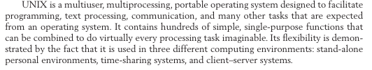

**Incorrect answers:**

**A is incorrect** because UNIX allows multiple users to access the system simultaneously.

**B is incorrect** because UNIX supports multitasking, meaning it can run multiple programs at once.

**D is incorrect** because UNIX is not limited to Apple hardware; it can run on many different systems.

.

**CSI 06**

***Question 6.*** What are the three fundamental structures of algorithms in programming that can be used to write any algorithm?

A) Sequence, Selection, Repetition  
B) Loop, Array, Function  
C) Conditional Check, Function, Linked List  
D) Infinite Loop, Condition, Branching

**Correct Answer: A  
Explanation:** The three fundamental structures in algorithms are:

**Sequence:** Executes instructions in a step-by-step order.

**Selection:** Makes decisions based on conditions.

**Repetition:** Repeats a set of instructions until a condition is met

Explain: Page 218  
https://lh7-rt.googleusercontent.com/docsz/AD_4nXcqmxCxaJOEzqm42oU224Rkt3kZjhfXJ05DyLb8zG6uLtptTU3cI0dVoiYa4bBDeXcQGHo0VBdhS8yoq5-1lKvuUhEe4IUj3QoGDM1nhNcr_XokixF9R8ky8M2EwDlopgarZ6fJ?key=1D0nK4yf4abfqvzjxuvzdVYV  
  
***Why incorrect:***

B) Loop, Array, Function → Array is a data structure, and Function organizes code but is not a fundamental algorithm structure.

C) Conditional Check, Function, Linked List → Function and Linked List are not control structures; they manage code and data, not algorithm flow.

D) Infinite Loop, Condition, Branching → Infinite Loop is not a standard structure; it’s usually an error. Branching is too broad and not a fundamental term.

**CSI 07**

***Question 7.***What does inheritance allow a specific class to do in object-oriented programming, according to the concept?

A) Inherit characteristics from a general class and slightly modify them.

B) Inherit characteristics from a general class and include new traits.

C) Inherit characteristics from a general class and completely override them.

D) Form a new class without connection to a general class’s traits.

ANSWER: **B**

Explain:

According to the book page 253 of the Inheritance section:

When a general class is defined, we can define a more specific class that inherits some of the characteristics of the general class, but also has some new characteristics.

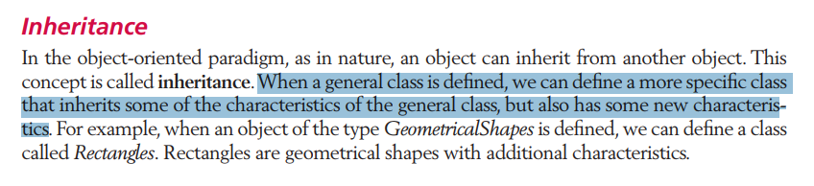

Analysis of Incorrect Options:

A. Inherit characteristics from a general class and slightly modify them:

**Wrong** because inheritance isn’t about modifying inherited traits—it’s about reusing them as-is or adding new ones.

C. Inherit characteristics from a general class and completely override them:

**Wrong** because inheritance keeps the original traits and builds on them, not replaces them entirely.

D. Form a new class without connection to a general class’s traits:

**Wrong** because inheritance requires a link—traits must be passed down. Without that, it’s not inheritance, just a new creation.

**CSI 08**

***Question 8.***What is the main difference between Glass-box testing and Black-box testing?

*A)* Black-box tests all independent paths, whereas Glass-box only checks some cases.

*B)* Glass-box mainly relies on boundary-value testing, while Black-box testing includes exhaustive, random, and boundary-value techniques.

*C)* Glass-box testing examines internal structures, while Black-box testing focuses on functionality.

*D)* Black-box testing is typically conducted by engineers focusing on inputs and outputs, while Glass-box testing is performed by external testers analyzing code structure.

ANSWER: **C**

Explain:

According to the book page 283 of the Glass-box testing section:

Glass-box testing (or white-box testing) is based on knowing the internal structure of the software.

According to the book page 285 of the Black-box testing section:

Black-box testing tests the functionality of the software in terms of what the software is supposed to accomplish, such as its inputs and outputs.

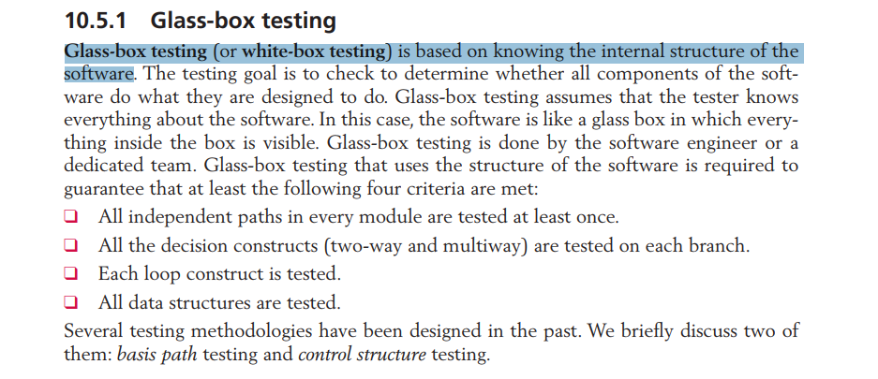

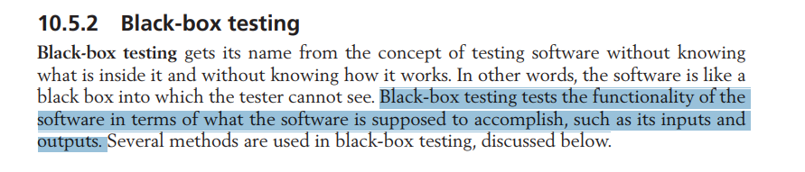

Analysis of Incorrect Options:

A. Black-box tests all independent paths, whereas Glass-box only checks some cases:

**Wrong** because Glass-box testing ensures "all independent paths in every module are tested at least once," while Black-box testing doesn’t focus on paths—it checks functionality without knowing the internal structure.

B. Glass-box mainly relies on boundary-value testing, while Black-box testing includes exhaustive, random, and boundary-value techniques:

**Wrong** because boundary-value testing is listed as a Black-box method, not a Glass-box one. Glass-box testing focuses on internal structures like paths and loops, not just boundary values.

D. Black-box testing is typically conducted by engineers focusing on inputs and outputs, while Glass-box testing is performed by external testers analyzing code structure:

**Wrong** because Glass-box testing is done by "the software engineer or a dedicated team," not external testers. Also, Black-box testing is about testing functionality, not who performs it.

**CSI 09**

***Question 9.***Which statement is TRUE about Records compared to Arrays?

A) Arrays contain multiple elements of different data types, whereas Records group related fields that must have the same data type.

B) Records are used for homogeneous data, whereas Arrays are for heterogeneous data.

C) A Record can have multiple fields of different types, but an Array contains elements of the same type.

D) Accessing an element in a Record is always faster than in an Array.

ANSWER: **C**

Explain:

According to the book page 292 of the Array section:

An array is a suitable structure when a small number of insertions and deletions are required, but a lot of searching and retrieval is needed.

According to the book page 298 of the Record section:

A record is a collection of related elements, possibly of different types, having a single name.

The elements in a record can be of the same or different types, but all elements in the record must be related.

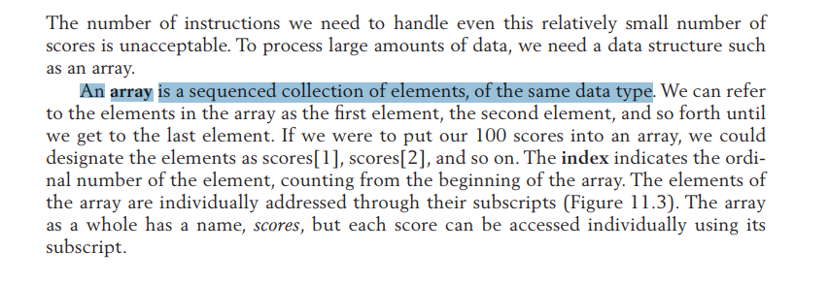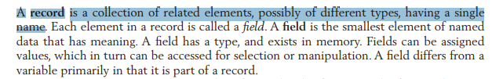

Analysis of Incorrect Options:

A. Arrays contain multiple elements of different data types, whereas Records group related fields that must have the same data type.

**Wrong** because Arrays contain elements of the same data type, whereas Records can contain multiple data types.

B. Records are used for homogeneous data, whereas Arrays are for heterogeneous data:

**Wrong** because Arrays are a homogeneous data structure, whereas Records are heterogeneous.

D. Accessing an element in a Record is always faster than in an Array:

**Wrong** because An Array is a linear data structure whose elements are stored associatively in memory. Accessing an element in an array is done directly by index (index) and has O(1) complexity (i.e. the access time remains the same regardless of how many elements are in the array).

A Record is a data structure that can contain many different types of data, organized into fields. The fields of a Record do not necessarily have to be stored contiguously in memory, and retrieving a field may require an additional mapping step to find the address of that field.

**CSI 10**

***Question 10.***A file system designer needs to optimize both **search speed** and **memory efficiency** while managing large volumes of records. Given the constraints of **limited memory** and **high lookup frequency**, which file organization method provides the best trade-off?

A) Sequential file with a linear search strategy to minimize indexing overhead.

B) Indexed file with a multi-level index structure for efficient record retrieval.

C) Hashed file using a carefully chosen hash function and a dynamic collision resolution method.

D) Hybrid structure combining indexed and hashed files, storing hash keys in an index table.

**ANSWER: C**

**Explain:**

According to *Foundations of Computer Science (2017)*, a **hashed file system** provides near-constant time complexity **O(1)** for lookups, making it ideal for scenarios where **fast access** is critical. A well-chosen **hash function** ensures even data distribution, while **collision resolution methods** like open addressing or chaining handle unavoidable key collisions effectively​.

Explain:

**Pages 355,358**

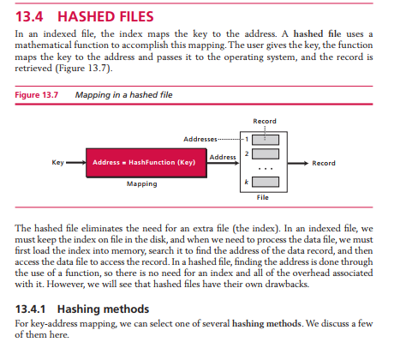

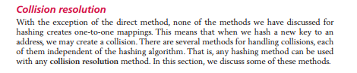

### Analysis of Incorrect Options:

**A:** *Wrong because sequential files require O(n) time for searching, making them inefficient for frequent lookups.*

**B:** *Wrong because multi-level indexing improves lookup time but consumes extra memory, which contradicts the memory constraint.*

**D:** *Wrong because combining hashing and indexing increases complexity and requires extra storage for the index table, making it inefficient under memory constraints.*

### CSI 11

***Question 11.***A large corporation implements a **multi-tier database system** to improve performance and security. A database engineer must decide where to apply **data access restrictions** while ensuring that users only see the data relevant to their roles. At which level of database architecture should these restrictions primarily be enforced?

A) Internal level, because it determines the physical storage of data and controls read/write operations.

B) Conceptual level, because it defines logical relationships and ensures entity integrity constraints.

C) External level, because it manages user-specific views and customizes access based on user roles.

D) Indexing level, because it optimizes data retrieval by restricting access to certain indexes.

**ANSWER: C**

### Explain:

According to *Foundations of Computer Science (2017)*, the **external level** is responsible for defining **user-specific views** and **restricting access to certain parts of the database**. This level customizes how different users see the data without modifying the underlying logical or physical structures​.

Explain:

**Page 373**

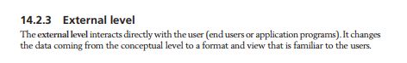

### Analysis of Incorrect Options:

**A:** *Wrong because the internal level only deals with physical storage and access methods, not user-specific data access control.*

**B:** *Wrong because the conceptual level defines the logical structure of the entire database but does not handle user-specific restrictions.*

**D:** *Wrong because indexing optimizes retrieval speed but does not directly control user access rights.*

### CSI 12

***Question 12.***A security analyst is designing a defense strategy to protect a government database from **confidentiality breaches, integrity violations, and denial-of-service (DoS) attacks**. Which combination of security measures is the most effective in achieving these goals?

A) Implement symmetric-key encryption for data confidentiality, hash-based message authentication for integrity, and firewall protection against DoS attacks.

B) Use asymmetric-key encryption for data confidentiality, redundancy checks for integrity, and load balancing to mitigate DoS attacks.

C) Deploy multi-factor authentication for confidentiality, digital signatures for integrity, and network segmentation for preventing DoS attacks.

D) Ensure confidentiality through robust physical security measures, maintain data integrity by conducting regular and thorough audits, and mitigate the risk of Denial-of-Service (DoS) attacks by implementing advanced antivirus software and proactive threat detection systems.

**ANSWER: A**

### Explain:

According to *Foundations of Computer Science (2017)*, security consists of three primary goals: **confidentiality, integrity, and availability**​.

* **Confidentiality:** **Symmetric-key encryption** is a fast and secure method to protect stored and transmitted data from unauthorized access​.
* **Integrity:** **Hash-based message authentication codes (HMAC)** verify that data has not been tampered with by using cryptographic hashing​.
* **Availability:** **Firewalls** help prevent **denial-of-service (DoS) attacks**, which can render systems unavailable by blocking malicious traffic​.

Explain:

**Pages 412**

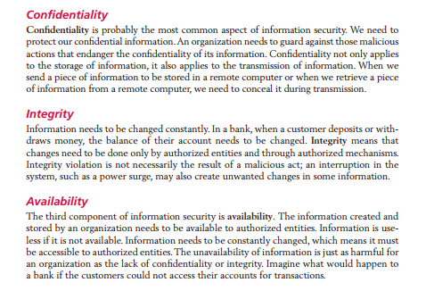

### Analysis of Incorrect Options:

**B:** *Wrong because redundancy checks do not provide cryptographic integrity guarantees, and load balancing mitigates but does not prevent DoS attacks.*

**C:** *Wrong because multi-factor authentication enhances security but does not directly enforce confidentiality at the data level.*

**D:** *Wrong because physical security and audits are important but do not provide real-time protection against cyber threats.*